Student Information System

Aim: To create a cloud-based Student Information System for using Zoho Creator to manage information.
Procedure:
- Log in to Zoho Creator and create a new application.
- Create a form named Student Information.
- Add fields such as Student Name, Register Number, Address, Phone, Age, Courses, and Grades.
- Create additional forms for Attendance Report, Progress Report, and Semester Mark Sheet.
- Enter student information and save the records. Use a C program separately if actual C code execution is required.
Implementation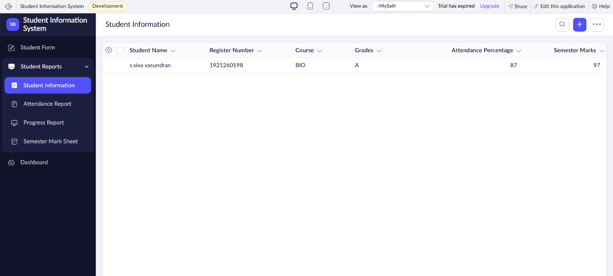

Result: Thus, a cloud-based Student Information System was created successfully to manage student academic records and reports.

